DAILY ASSESSMENT FORMAT

|  |  |  |  |  |  |
| --- | --- | --- | --- | --- | --- |
| Date: | 27/07/2020 | | | Name: | Persis P |
| Course: | Coursera | | | USN: | 4AL17EC069 |
| Topic: | • | Basic | Statics | Semester & Section: | 6 & B |
|  |
| Github  Repository: |  | | |  |  |

SESSION DETAILS

Session images

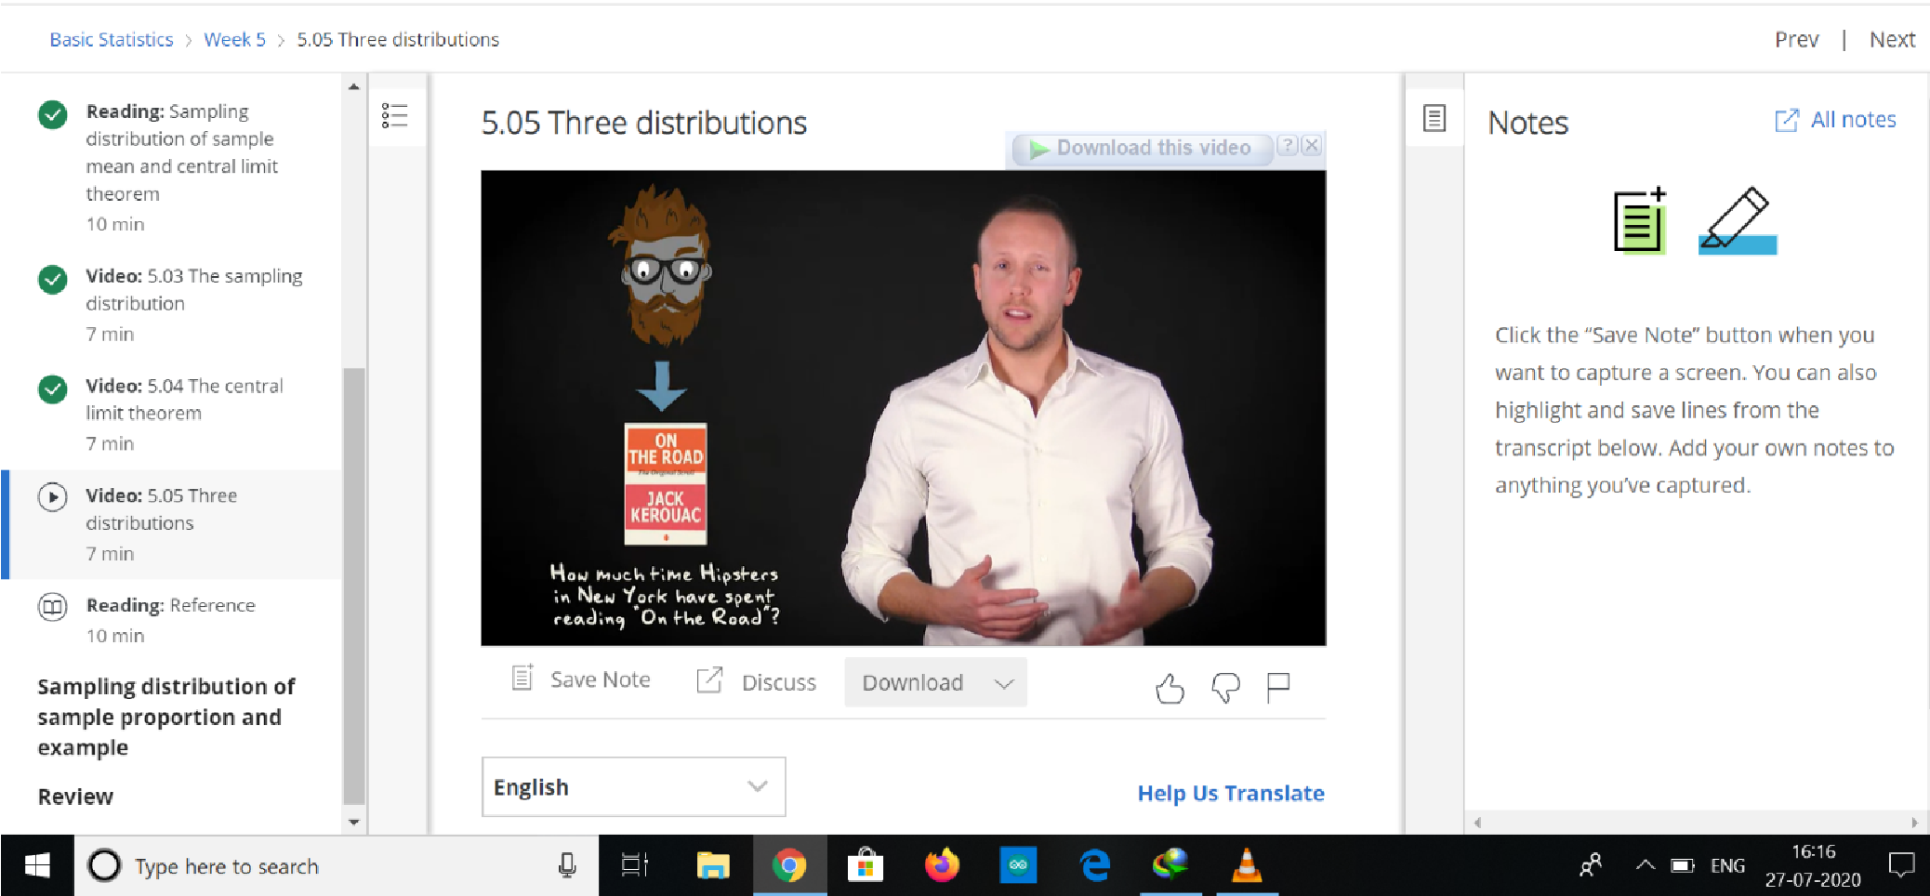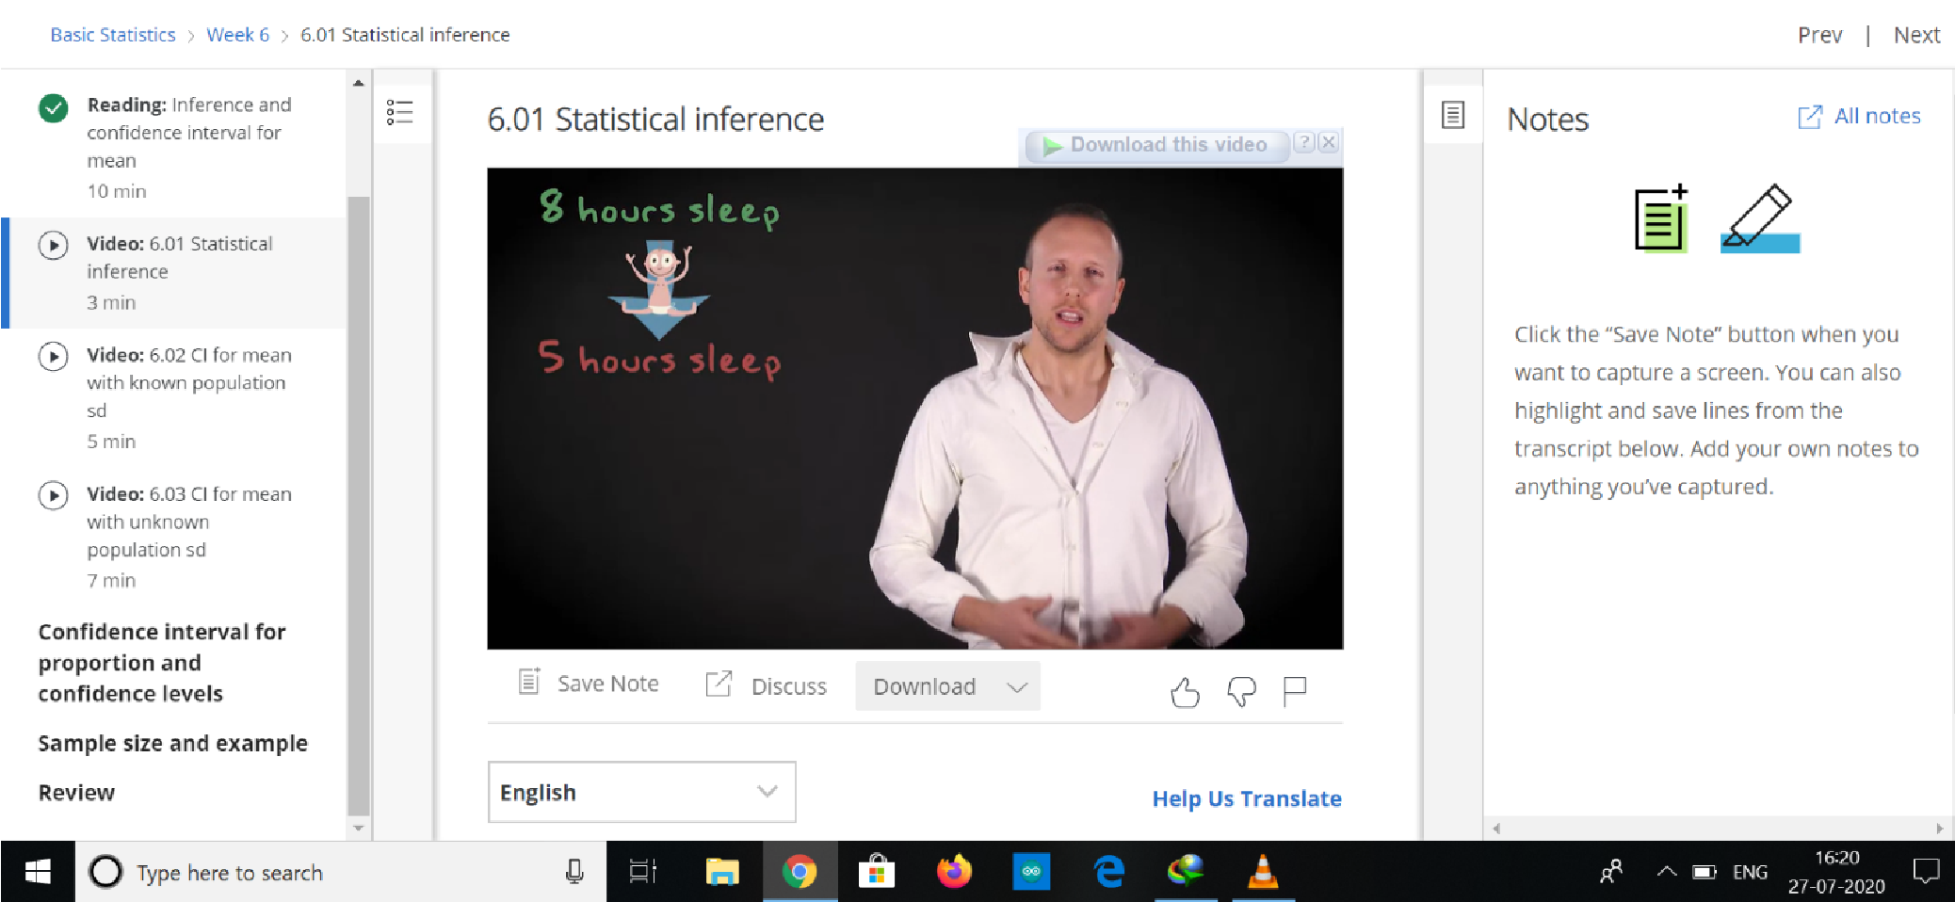

|  |
| --- |
| Report:   1. AN OVERVIEW OF BASIC STATISTICS Statistics being a branch of mathematics is often associated with anxiety or unease particularly among students who fear mathematics for one reason or another. Well, if you are one of those students then sit, relax, and read this chapter first as it will take you through a journey in which you will discover a world of fun, excitement, vision, and creativity. With minimum mathematical details, this chapter introduces key concepts and universal terms that are used among statisticians and briefly discusses common statistical tools, their underlying principles and their practical merits. 2. Why should you learn statistics? In the general sense, statistics is the science of dealing with variability, uncertainty, and subjectivity to produce objective and quantitative information that can assist in making reliable decisions about numerous situations in life. Globally, statistics is a key tool in governments and organizations activities. The reason we need statistics is that we are living in a world of numbers, or more precisely a world of data. 3. What is statistics? “The science and art of reading, describing, and manipulating data, which represents variables so that practical observations about a population can be made from a sample drawn from the population, and guidelines can be established to allow making precise and accurate conclusions about a certain process or system” Statistics:   between science and art ,Art stems from extrapolation, interpretation, and judgment It is well-known, statistics does not provide causes and effects; it only yields analysis outcome based on the data used. It is then your job to provide causes and effects. |
|  |
|  |